**Citi Bike Analytics:**

* **For these data analysis – the first six months of the year 2018 is chosen**

**The total number of riders for this period is :**

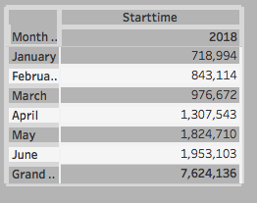

* **The total growth in percentage during the first six months of 2018**:

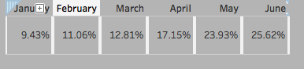

* **Citi bike users short term customers vs annual subscribers histogram:**

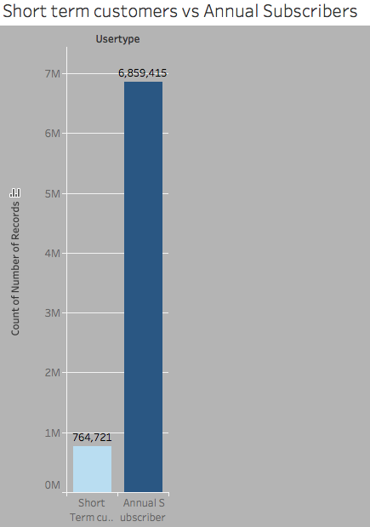

* **Peak hours for bike use**

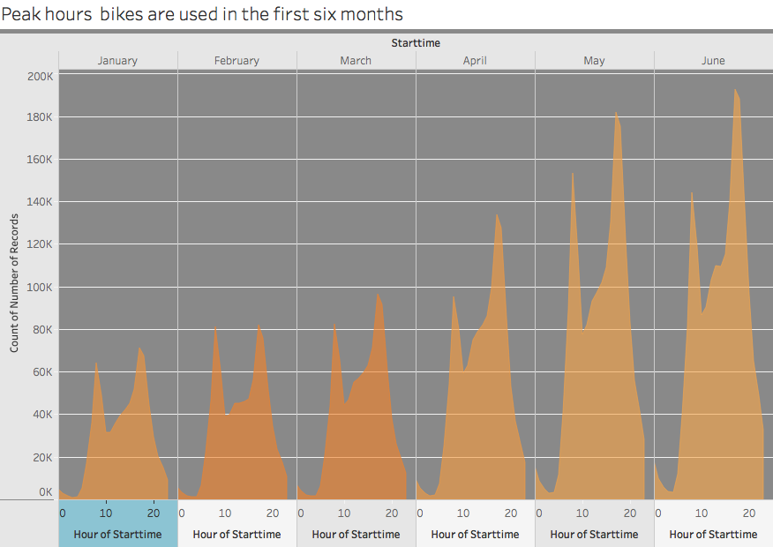

There is always a sharp rise in usage in rush hours – But the greatest usage is about 5:00 in the afternoon

* **All bike stations which are active**

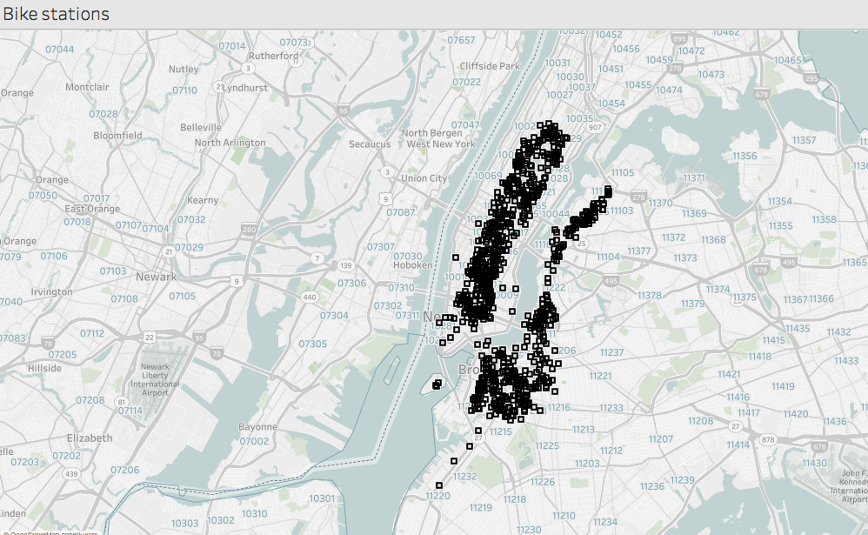

* **Top ten stations for starting a journey using bikes:**

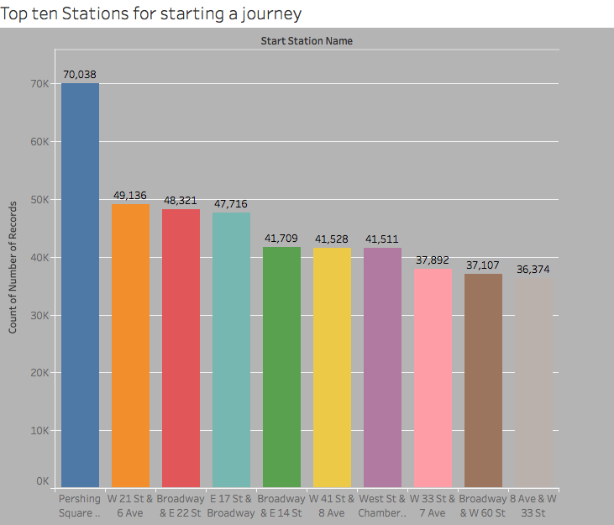

* Map showing the top ten beginning a journey in bike stations

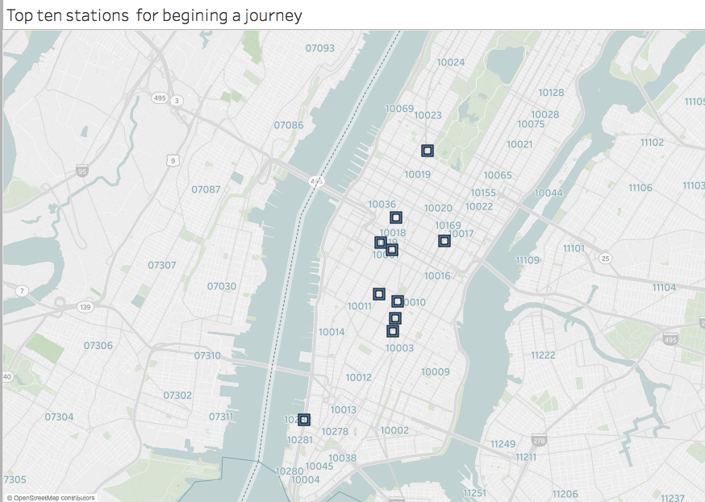

From the data it can be seen all the top starting stations are all in the central New York/Manhattan area.

* **Top ten stations for ending a journey**

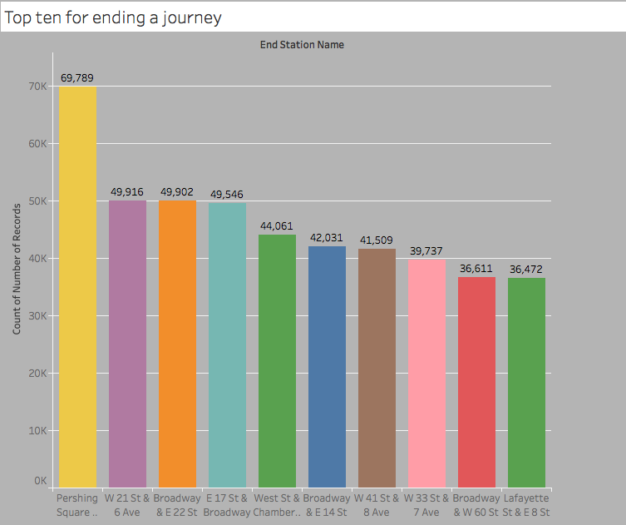

* **Map showing top ten stations in ending a journey**

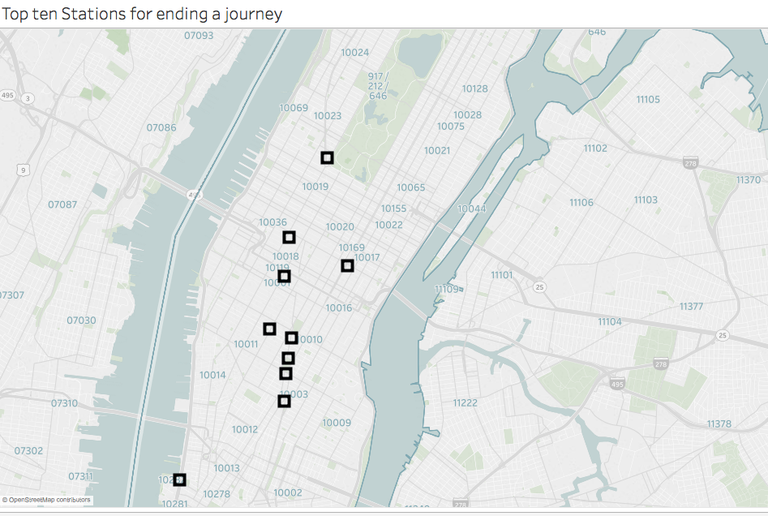

The most frequent ending stations are almost very close to the most starting stations , and they are all inside the Manhattan area.

* **Bottom ten stations for starting a journey**

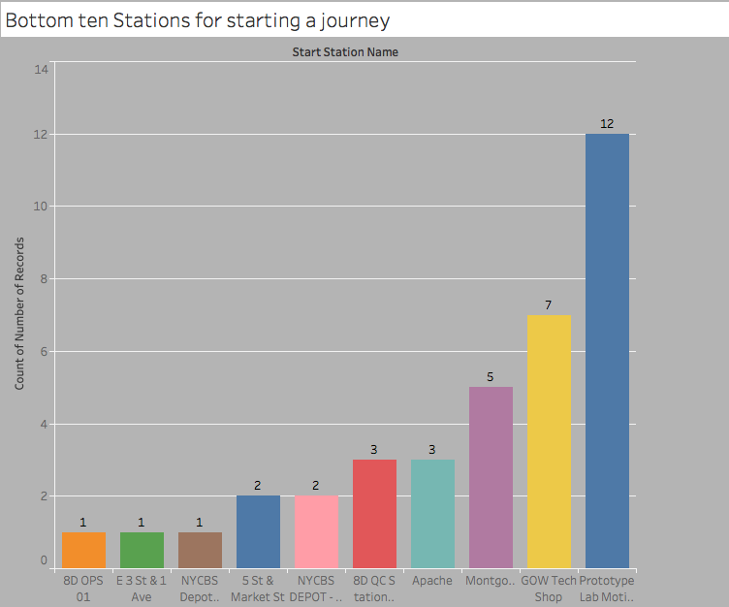

* Map showing the bottom ten stations for ending a journey

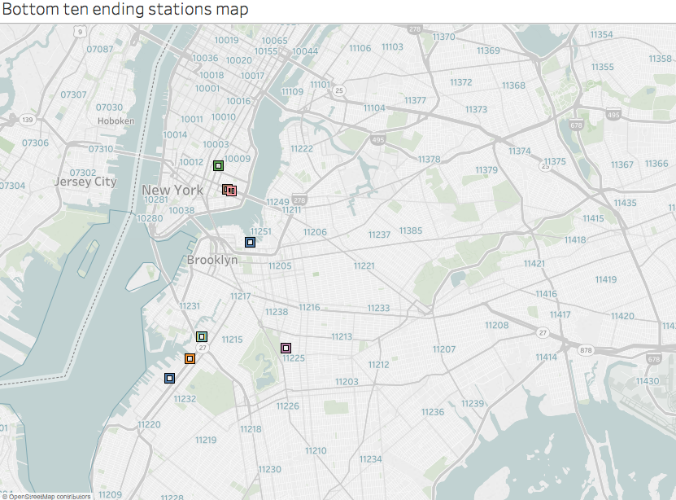

* **Gender Breakdown of bike users:**

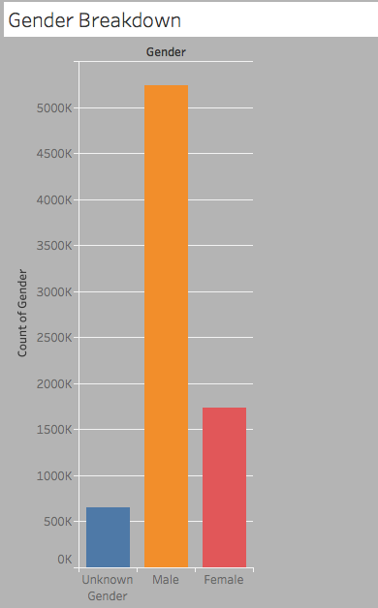

* **How has gender outreach affected ridership for the first six months?**

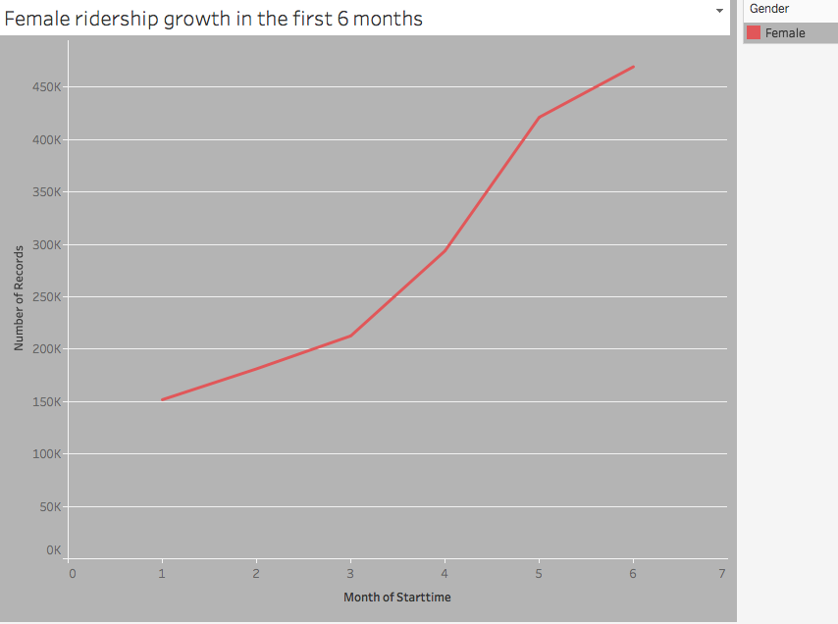

It shows growth – it can be concluded as effective

* **Trip duration by age:**

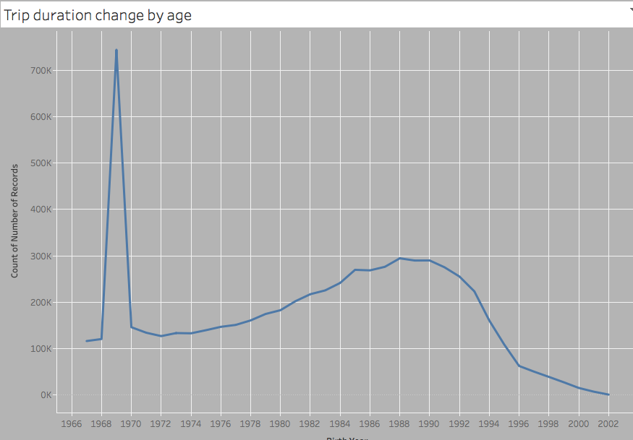

* **The most bikes used**

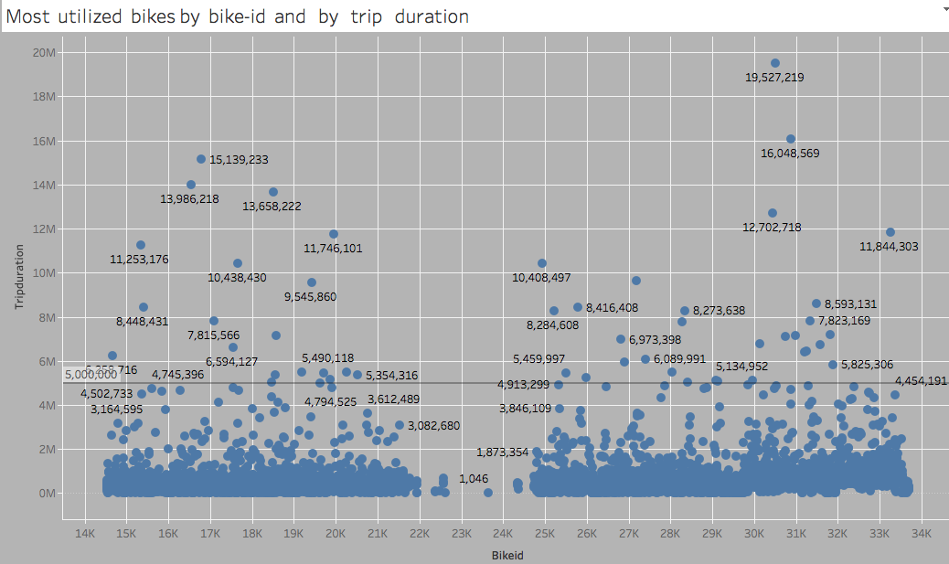

Those bikes which are used above the average line should be ready for inspection or maintenance

The average usage about 5000 sec and is shown by the straight horizontal line